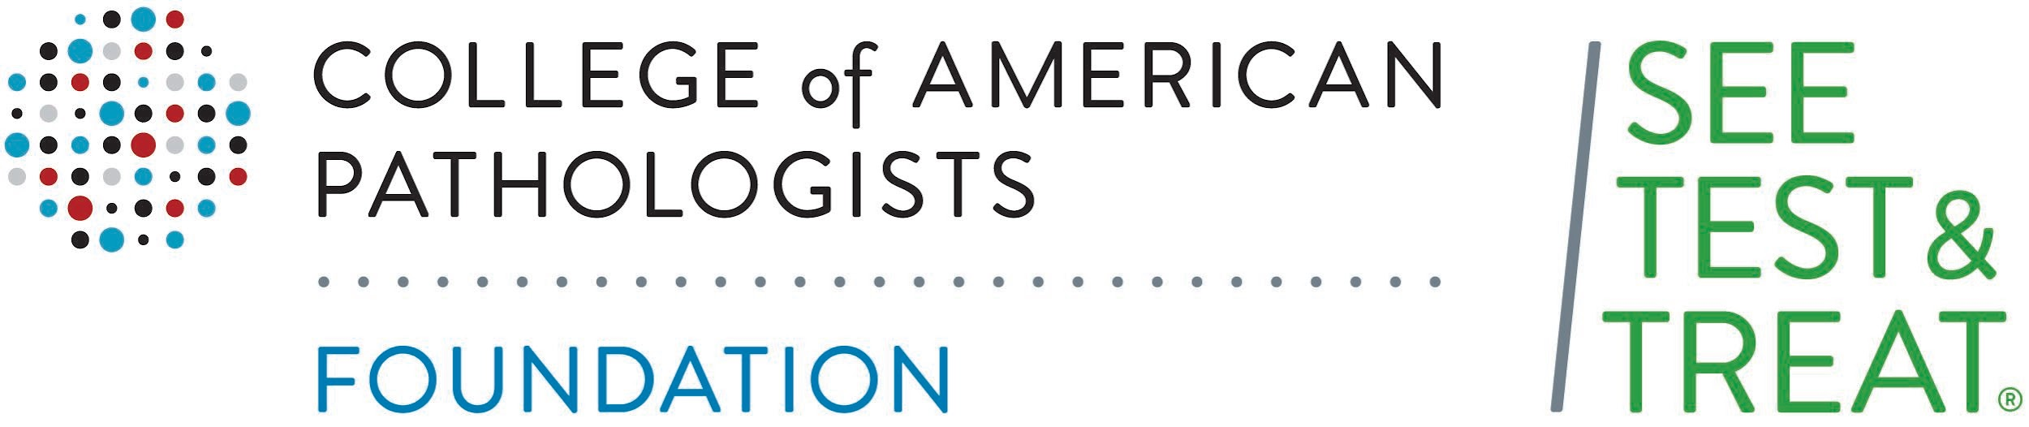

POST-PROGRAM SURVEY

1. What Screening(s) did you get today? (select all that apply) (EDIT BASED ON SCREENING OFFERINGS)
- Cervical cancer screening
- Breast cancer screening
- Colon cancer screening
- Lung cancer screening
- Hyperlipidemia (Blood cholesterol and fat) screening
- Diabetes screening
- Sexually transmitted diseases or Infection screening
- Iron deficiency anemia screening

2. Did you participate in the health fair today?
Yes No Unsure

3a. Did you meet with a pathologist today?
Yes No Unsure

3b. Which of the following best describes what you learned from the pathologist (choose all that apply):
  - What a pathologist does
  - How to take care of my health better
  - What to do if I get an abnormal result from my screening
  - Other _______________________
  - I did not meet with a pathologist
  - I did not learn anything from the pathologist

4. How important do you feel it is to go to the doctor for regular check-ups even if you are not sick?
Very important Somewhat important Not important at all

5. After attending this event, do you better understand how to lower your chances of getting (EDIT BASED ON YOUR SCREENING OFFERINGS)
a. Cervical cancer?
Yes Somewhat/Maybe No
b. Breast cancer?
Yes Somewhat/Maybe No
c. Colon cancer?
Yes Somewhat/Maybe No
d. Lung cancer?
Yes Somewhat/Maybe No
e. Hyperlipidemia (High Blood cholesterol and fat) ?
Yes Somewhat/Maybe No
f. Sexually transmitted diseases or infections?
Yes Somewhat/Maybe No
g. Iron deficiency anemia?
Yes Somewhat/Maybe No
h. Diabetes?
Yes Somewhat/Maybe No

6. Do you know where you can go for (EDIT BASED ON YOUR SCREENING OFFERINGS)

a. Cervical cancer screening?
Yes Somewhat/Maybe No
b. Breast cancer screening?
Yes Somewhat/Maybe No
c. Colon cancer screening?
Yes Somewhat/Maybe N
d. Lung cancer screening?
Yes Somewhat/Maybe No
e. Hyperlipidemia (Blood cholesterol and screening) screening?
Yes Somewhat/Maybe No
f. Sexually transmitted diseases or infection screening?
Yes Somewhat/Maybe No
g. Iron deficiency anemia screening?
Yes Somewhat/Maybe No
h. Diabetes?
Yes Somewhat/Maybe No

7. Do you understand what a pathologist does?
Yes / Somewhat / No

Thank you for completing this survey !
Please give this form to XXX to receive XXXX.

