SPIN, TEST & TREAT GAME

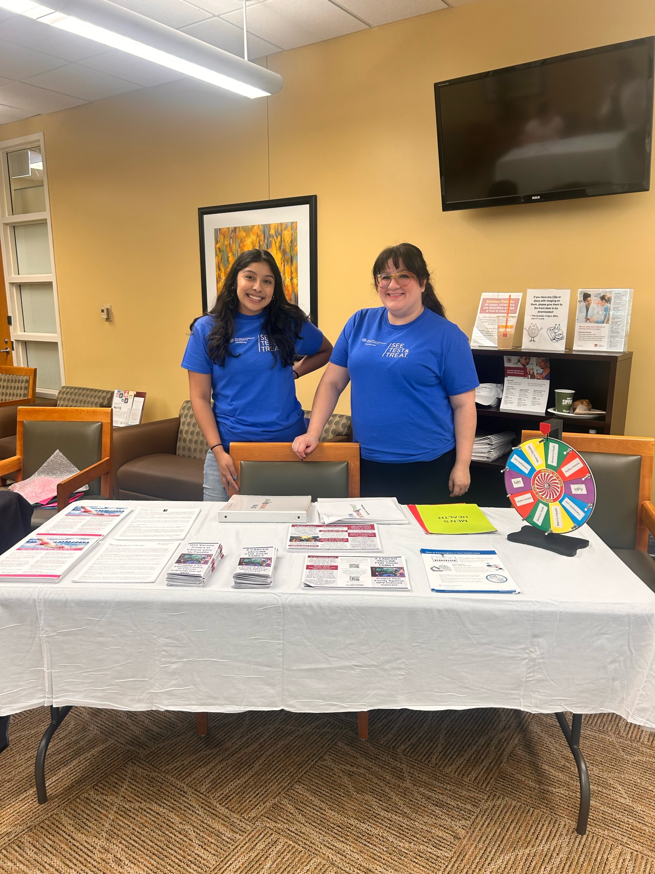

Materials
1 Spin, Test & Treat Wheel
1 English Binder with Questions
1 Spanish Binder with Questions
2 Answer Spreadsheets
Giveaways
CAP Foundation Information Handouts:
- Healthy Lifestyles
- Men’s Health
- HPV Education
- Pathologist handouts

Game (Spin, Test & Treat) Rules for Volunteers
- Let the participants know that they can win a prize for getting 2 out of 3 questions right
- Have participant spin the wheel- whatever category it lands on, ask them a question from the category and give them the handout that pertains to that question. Have them repeat.
- They can choose a prize after answering 3 questions (it’s ok if they get some wrong, I’ll let you make a judgement call)

