SOCIAL MEDIA GUIDE

Twitter Guidelines
- Please include the CAP’s Twitter handle in your tweets: @capfndn
- Use ideal length to increase likelihood of a retweet: 150-300characters, include photos
- Remember that spaces, dashes, and everything else count as characters
- Character-saving tips:
  - Use a semicolon (;) or ampersand (&) instead of the word “and”
  - Use lab instead of laboratory
  - Don’t worry about Dr.’s first names or FCAP
- Additional Tips:
  - Compose your tweet in long form, and then edit out adjectives, articles, and any unnecessary words and characters. Think: “clear, concise, and compelling, and then be even more concise.”
  - If possible, post a tweet that “tags” the hospital and any other organizations involved in event. You can do a search at the top of the Twitter homepage to find these handles. For example:

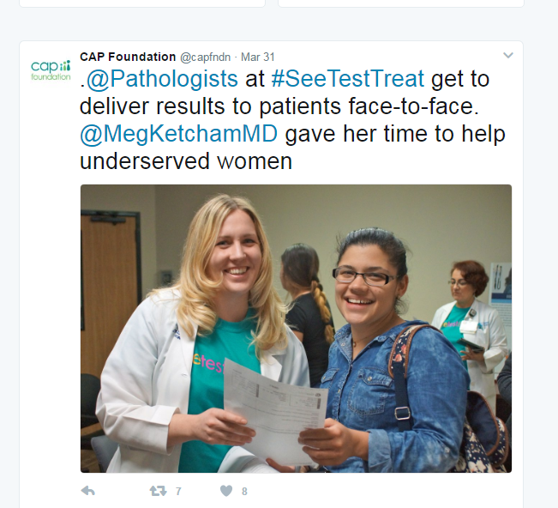

Facebook Guidelines:
- Like and post your See, Test & Treat event highlights and status updates to the CAP Facebook page (facebook.com/capfndn)
- While Facebook status updates can accommodate thousands of characters, aim to be concise
- Accompany each post with a photo.
- Just like Twitter, tag your institution if it is on Facebook and be sure to tag the CAP Foundation.

Using Boosted Content to Boost
See, Test & Treat® Registration

Intro to Targeted Data on Facebook
Facebook uses the demographic information that users provide to help advertisers reach audiences. Without realizing it, we provide detailed information to Facebook in order to help paid advertisers reach us and segment us into audiences. See, Test & Treat host sites can use this affordable means to reach a bigger audience of potential patients by using even the most basic information users provide to Facebook:
- Geographic
- Interests/Likes
- Demographic

Boosting Your Post
You can boost a new or existing post from Facebook by clicking the blue “Boost” button that shows up at the bottom of each post. A pop-up will open for you to navigate the Boost options and start targeting your audiences.
- Currently, boosts are only available for Pages on Facebook. An individual person will not be able to boost their personal posts. Host sites will need to create a post on their Institution’s page, Community page, etc.

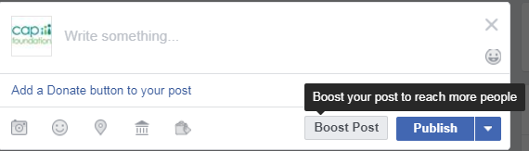
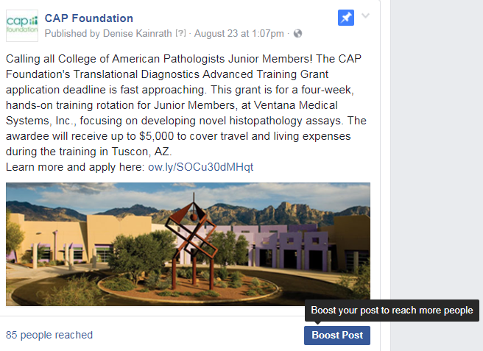
Boost on an Existing Post Boost on a New Post

Choosing What to Include
The boosted post should be detailed, but to-the-point. Use the image associated with the post to include some information to supplement the text that will be added. Stay within 100-150 words of text and 100 words or less on the image (see below for example post).

Facebook allows you to add a button to the post as a “call-to-action,” prompting viewers to click a button that allows them to learn more, sign up, etc. This is a great place to direct people to a survey or event page where they can RSVP and you can collect contact information.
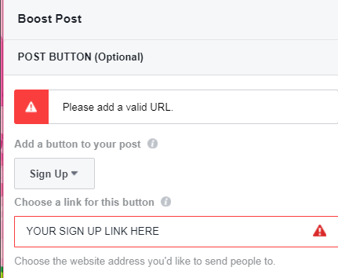
Collecting Information and Links
Survey Monkey is a survey collector to ask pre-screening questions and collect contact info, preferred appointment times, etc. Eventbrite is an event-based website that can help pre-register women and also collect pre-screening and contact info.

Does your Boosted Post have:
- An eye-catching image
- A link to a landing page
- Who qualifies?
- When is the program?
- What screenings?
- Where is the program happening?
- How to register?

Example post:
Next Saturday (9/16), Central Hospital will be offering FREE breast and cervical cancer screenings to women ages 30-64 who are uninsured. Screenings are by appointment only. Call 888-584-7888 to make an appointment and verify eligibility, or visit www.test.link.com/STT

Selecting a Target Audience
Pages are able to target by gender, location and age range, as well as demographic and personal information by selecting “People you choose through targeting” as the audience. Other options include those who like your page, and those who like your page and their friends.

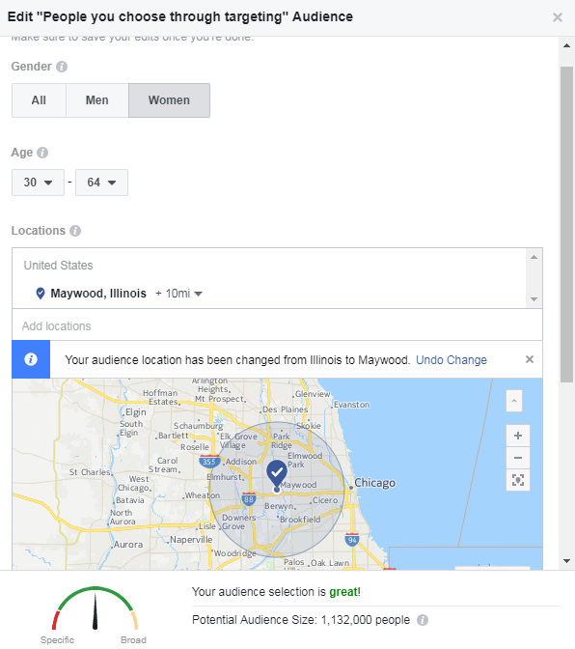
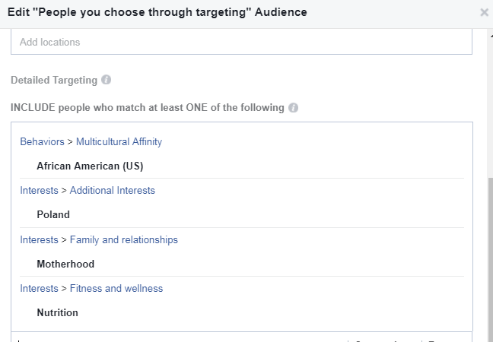
Females of a certain age living in a small radius from the site may yield a large audience; there are more than 1 million 30-64 year old women living 10 miles from Maywood, IL. By selecting more than just geographic and demographic information, this boosted post is able to reach a more specific audience.

The audience above could encompass a 31 year old African-American woman from Maywood who likes the hip-hop and R&B radio station in Chicago. Additionally, it could capture a 40 year old Polish mother who has liked a Polish grocery store in the surrounding area. Additionally, these people might be likely to share the post themselves with their personal Facebook networks.

Choosing a Budget & Duration
Facebook will prompt you to enter a budget and a desired timeframe for the boosted post to show up. Choosing when to boost a post is definitely audience-specific and may differ from site to site. Additionally, settling on a budget may depend on how many people you want to boost the post to, how close to your target registration you are, and how far out from the program you are.
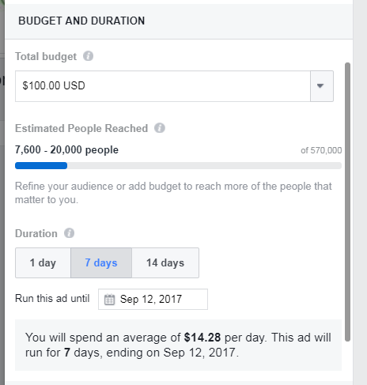

Suggested Boost Time & Duration
Boost 1: Capture the early-birds and get the word out about the program, at least 6 weeks in advance of the program.
- Boost for the one week or two week option to get a wide spread of users.

Boost 2: Boost registration toward the end of the registration period and overbook the program to account for no-shows.
- Boost for a shorter time frame to ensure that the message is being seen often by many people.
- Select your audience based on any gaps in registration numbers so far; segment to a younger or older audience if many people from one age group have already registered and the program needs older/younger patients as well.

Resources
www.eventbrite.com - Create and list your program; use the registration feature to capture pre-registration information from potential patients.
www.surveymonkey.com - Design a survey or pre-screener to collect information about potential patients.
CAP Foundation Operations Manager DKainra@cap.org 847-832-7718
CAP Foundation Facebook- https://www.facebook.com/capfndn/
CAP Foundation Twitter- https://twitter.com/CAPFndn

