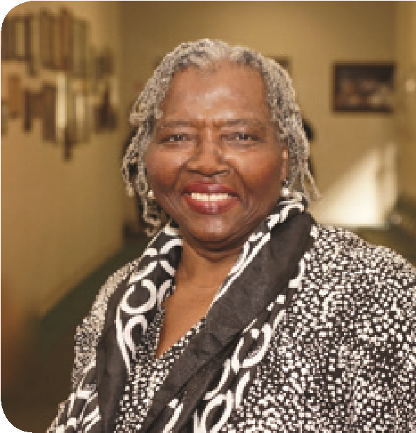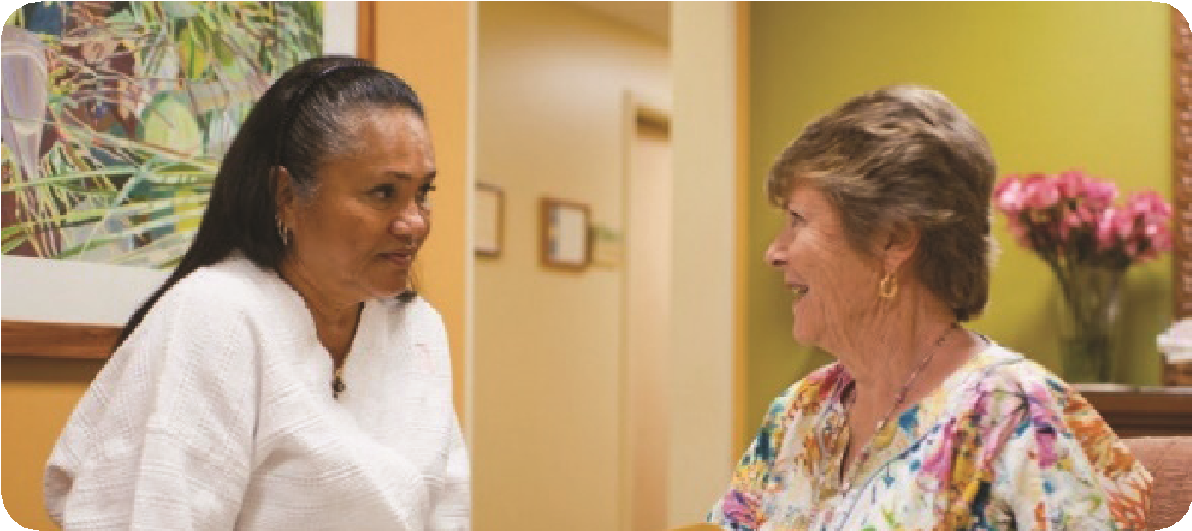

**A prevention and health education  
program for uninsured and underinsured women.**

**Opportunity to receive free:**

**Other services offered:**

**Spend the Day with Us!**

**How does See, Test & Treat work?**

**Free Screenings**

See, Test & Treat offers free cervical and breast screening as well   
as other information and education on women’s health.

**Why Is This Important**

When you maintain a healthy lifestyle, you are reducing your risk for cancer. Regular health screenings can help you limit the risks and improve your health.

**Receive Prompt Results**

You will receive prompt results to ensure timely follow-up.   
Clinicians will be onsite to discuss any findings or questions regarding follow-up care. We hope to make this an enjoyable and informative experience, helping you establish and continue care as needed.

women will be able to establish and continue care as needed.

foundation.cap.org

Sponsored by:

• Health education resources  
• Preventative screening

• Cervical cancer screening (Pap test),  
 ages 21-64-same day results  
  
• Mammogram (age appropriate),   
 ages 40-64 – results within 3-5 days

Date:

Time:   
Facility Name:   
Address:

**Phone number:**

See, Test, & Treat  
**Name of Facility**